

# PROJECT REPORT

Reducing Excess Inventory using Lean Six Sigma tools at Kateeva

**ISE-251** MANAGING THE LEAN ENTERPRISE IMPROVEMENT PROGRAM

Team: Dhaval Ajay Bhatt, Saloni Goradia, Shreya Milind Kulkarni, Adarsh Vinod Nair

**ABSTRACT**

The objective of our Lean improvement project is to minimize the overall inventory cost incurred at Kateeva and prepare a Business Process Improvement (BPI) plan to add value to the organization. Through Define, Measure, Analyze, Improve, Control (DMAIC) analysis, Value Stream Mapping and Root Cause Analysis, we suggested solutions to mitigate process issues faced by the Company. The project provides a detailed study of various phases such as identification of problems, the collection of data and recommendations provided by the team. The report focuses on reducing the inventory cost and service time by streamlining the workflow and in turn improving the revenue. The implementation of control charts comprising of before and after phases showcase effectiveness of the improvements made. On identification of various other shortcomings and unnecessary processes, probable solutions were recommended. However, the area of focus remains on reducing the inventory cost and lead time of the Company. Finally, methodologies of Lean were successfully implemented thereby minimizing the overall inventory cost at Kateeva.

**Table of Contents**

Table of Contents

PROJECT CHARTER 1

Charter 5

Purpose 5

Overview and Problem Identification 5

Scope 6

Out of scope items: 6

Deliverables 6

Issues 6

Constraints 6

Measures 7

Team and Resource Identification 7

Overview: Lean in inventory management 7

Define phase: 7

Measure Phase: 9

SIPOC: 9

Analyze Phase: 13

Pareto chart analysis: 14

Fishbone diagram: 15

5-WHY ANALYSIS 17

Value Stream Mapping 18

Value Stream Mapping before the process improvement 18

Improve Phase: 19

FMEA: 20

Value Stream Mapping after the process improvement 22

Control Phase: 23

Control chart 23

Hypothesis Testing 24

Environmental and Economic effects: 26

Conclusion 26

References 26

Appendix 27

# **Charter**

## Purpose

* The purpose of this project is to apply the DMAIC (Design, Measure, Analyze, Improve, Control) tools to reduce the overall inventory cost incurred at Kateeva, located at Newark, CA. The main objective is to make recommendations that will minimize the loss in the company’s revenue and reduce transportation costs. Utilizing Lean Improvement tools, we aim to provide recommendations that can help reduce the excess inventory and lower the costs associated.
* As per the current processes, Lead time at Kateeva is significantly huge and a finished product usually takes months to produce. The purpose of this project is to help Kateeva reduce the overall lead time and remove any wastes or defects in their production systems.

## Overview and Problem Identification

OLED technology has redefined the digital screen. Kateeva develops world’s first inkjet printer for ideal OLED mass production. Their primary customers are located in China, Taiwan, and Korea. Kateeva starts procuring for 20% of the inventory before finalizing the deal with the clients. If the deal is not confirmed, the inventory is of no use to the company until they get a similar opportunity. Hence, excess inventory is the burning issue for the startup right now.

Inventory cost and waiting time has been identified as the two major problems. Upon interacting with the concerned professional, it has been observed that the process of manufacturing OLED printers takes a minimum of 20 months to complete. So, an expensive floor space is required to store the materials which lead to high costs. Another aspect found upon taking feedback is that the parts come to the US from 3 countries. Therefore, the time taken to reach these parts to the shop floor takes more than 35 days. By reducing the service time, we can streamline the workflow and in turn improve the revenue.

## Scope

Rearranging inventory storage locations, inventory management techniques for parts availability, make recommendations that can help minimize the business cost, mitigate the need for expensive floor space for the storage of the raw materials, parts, and reserved obsolete inventories. Also, investigating and improving supplier quality of the procured parts and raw materials can help in countering the excess inventory problem.

## Out of scope items:

Visit of the manufacturing floor to inspect/measure the quality of parts, improving business models with customers, improving supplier’s purchasing contracts.

## Deliverables

* Reducing excess Inventory by at least 15% and overall cost reduction
* Reducing average lead time by 10% for manufacturing/assembling OLED Inkjet Printers
* Suggest inventory management techniques

## Issues

This project has to be completed in a limited timeline of 3 months. This is a comparatively short time for monitoring any improvement. Detail inspection has to be done to check the quality of Inventory Management.

## Constraints

As limited data is available from Kateeva, due to the non-disclosure agreement, only suggestions given by the team would be used to make any changes for the inventory management. Another constraint is transportation issues between the three manufacturing/assembly units.

## Measures

Measures of success for this project will be a reduction in lead time, a reduction in overhead cost for inventory management, reduction of obsolete inventory, improved accuracy and visibility into existing dead stock.

## Team and Resource Identification

The Team comprises of an SME from Kateeva who will measure the excess inventory before and after improvement, a Project Manager who will be monitoring overall timeline and deliverables. The Team will identify and collect data using existing ERP systems and by interviewing employees and SMEs at Kateeva. The Team will work as a facilitator for this project rather than driving improvements. The Team will help value stream leaders and SMEs to better interpret the improvement opportunities.

# **Overview: Lean in inventory management**

Lean inventory focuses on inventory control from a different angle. Instead of stocking up the storage room with whatever might be needed, lean inventory approaches try to remove any excess inventory as well as wastes and improves the system by retaining only items which are needed in a specified time frame (“Trujillo”, 2018). For spare parts and raw materials inventory, excess and dormant stock are chronic supply chain problem costing Kateeva millions of dollars.

# **Define phase:**

DMAIC (Define, Measure, Analyze, Improve and Control) is a Six Sigma approach but can be applied as an individual improvement process such as lean ("Applying DMAIC to Inventory Problems | Quality Digest," 2010). DMAIC is used for improving, revamping and sustaining business processes. The Define Phase is the first phase where the problem statement and the goals of the project are defined. Suppliers Inputs Process Outputs Customers (SIPOC), and Voice of the Customer (VOC) the various tools which fall under DMAIC approach. A brief description of the issues at Kateeva have been listed below.

*(Table 1: List of Issues)*

|  |  |  |  |  |  |  |
| --- | --- | --- | --- | --- | --- | --- |
| Issue | Description | Date of Issue identified | Date of issue resolved | Who Resolved it? | Status | Comments |
| Excess Inventory | Data was collected, analyzed and verified with the concerned manager. | 09/28/2018 | 11/23/2018 | Team | Closed | Varied as per incoming of the orders. |
| Inventory Cost | Data Collection from Inventory Control Manager. | 09/28/2018 | 11/23/2018 | Team | Closed | Focus on minimizing obsolete inventories. |
| Lead Time | Data was collected from First Line Managers. | 09/28/2018 | 11/23/2018 | Team | Closed | Recommendations on rearranging the inventory storage locations |
| Expensive Floor Space (Inventory) | Data collection from Inventory Control Manager. | 09/28/2018 | 11/23/2018 | Team | Closed | Keeping a track of the exact inventory required. |

# **Measure Phase:**

## SIPOC:

SIPOC diagram is a high-level process map which is designed to get a birds-eye view of the high-level core processes. The high-level processes at Kateeva are shown in the SIPOC diagram below. Since, Kateeva orders the parts and material from various suppliers and also does In-House manufacturing of some parts. As soon as the customer order is received, purchase order is created to order the parts from suppliers based on supplier evaluation and selection. Most of the parts used are very delicate, expensive and high in quality since they will be used in disposing OLED materials on glass via inkjet printing principles ("Inkjet printer - DDL Wiki," n.d.). After the small parts are manufactured/received from suppliers, the OLED printer is assembled, the process which usually takes months. SIPOC is crucial to create before VSM as it defines the boundaries of the system and the process areas to focus on for Lean improvement.

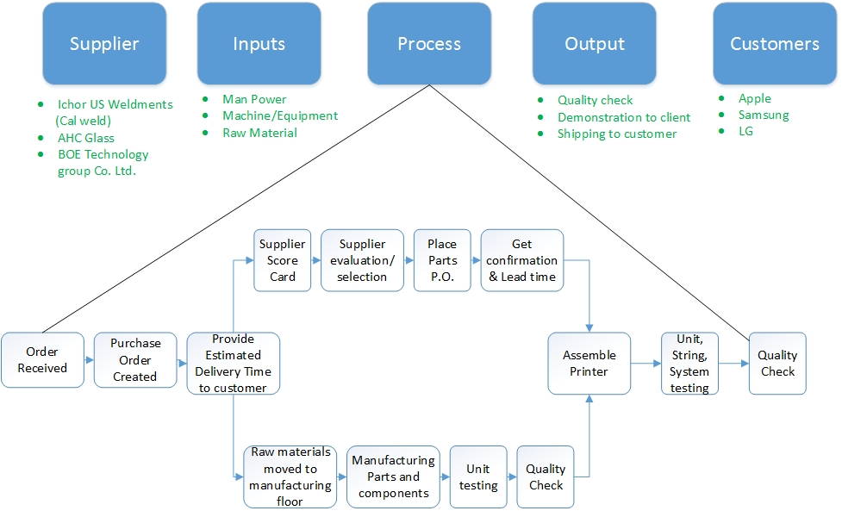

*(Figure 1: SIPOC)*

Measure is the second phase in implementing Lean Six Sigma improvement strategy. Measure phase is utilized to transfer the data into quantifiable terms. In order to determine the relative performance of the current system, a data collection plan is very crucial. It also helps validate the current measurement system. Interviews with Kateeva Personnel were conducted to gain insights into the current inventory management activities. The quantitative data for YEILDJet printer is shown in the table below:

Data Collection: Data collection is the essential part of DMAIC analysis ("Applying DMAIC to Inventory Problems | Quality Digest," 2010). All process improvements can be done after detecting the issues in the data what is obtained.

*(Table 2: Data Collection)*

|  |  |  |  |  |  |  |
| --- | --- | --- | --- | --- | --- | --- |
| Description | Product IDs(before) | Quantity | Warehouse | Aisle | Bin | Level |
| Screw | SA_20003 | 12 | Newark | 1 | 1 | 1 |
| Bolts | SA_20007 | 12 | Newark | 1 | 1 | 3 |
| Cables | SA_20005 | 13 | Newark | 3 | 1 | 2 |
| Labels | SA_20001 | 20 | Newark | 2 | 1 | 4 |
| Lid | VA_11001 | 10 | Newark | 2 | 2 | 2 |
| Nozzle | VA_11004 | 6 | Fremont | 3 | 2 | 2 |
| Input Buttons | VA_11010 | 5 | Fremont | 2 | 2 | 1 |
| Roller Set | VA_11007 | 15 | Fremont | 4 | 2 | 1 |
| Springs set | VA_11005 | 25 | Newark | 4 | 1 | 1 |
| Lid sensor | VA_11009 | 16 | Newark | 4 | 1 | 4 |
| Inkjet cartridge craddle | IS_5001 | 23 | Fremont | 2 | 3 | 2 |
| Glass holding chasis | IS_5009 | 9 | Fremont | 2 | 2 | 1 |
| Temperature controller | TA_120 | 6 | Newark | 1 | 3 | 3 |
| Heating and cooling system | TA_130 | 12 | Newark | 2 | 3 | 4 |
| Printer head | TA_150 | 29 | Fremont | 3 | 3 | 1 |

*(Table 3: Data Collection: Cost)*

|  |  |  |  |  |  |  |  |  |  |
| --- | --- | --- | --- | --- | --- | --- | --- | --- | --- |
| Description | Product IDs | Average inventory | Cost of capital | Space and Utilities | Admirative cost | Material Handling | Insurance | Total holding cost | Total Inventory cost |
| Screw | SA_20003 | $ 1,300.00 | $ 4,500.00 | $ 100.00 | $ 100.00 | $ 250.00 | - | $ 450.00 | $ 4,950.00 |
| Bolts | SA_20007 | $ 1,990.00 | $ 5,000.00 | $ 100.00 | $ 100.00 | $ 250.00 | - | $ 450.00 | $ 5,450.00 |
| Cables | SA_20005 | $ 1,632.00 | $ 3,300.00 | $ 100.00 | $ 100.00 | $ 250.00 | - | $ 450.00 | $ 3,750.00 |
| Labels | SA_20001 | $ 2,697.00 | $ 5,000.00 | $ 100.00 | $ 100.00 | $ 250.00 | $ 50.00 | $ 500.00 | $ 5,500.00 |
| Lid | VA_11001 | $ 4,500.00 | $ 25,000.00 | $ 500.00 | $ 100.00 | $ 250.00 | - | $ 850.00 | $ 25,850.00 |
| Nozzle | VA_11004 | $ 3,540.00 | $ 30,000.00 | $ 300.00 | $ 100.00 | $ 250.00 | $ 100.00 | $ 750.00 | $ 30,750.00 |
| Input Buttons | VA_11010 | $ 9,836.00 | $ 200,000.00 | $ 1,000.00 | $ 100.00 | $ 600.00 | $ 250.00 | $ 1,950.00 | $ 201,950.00 |
| Roller Set | VA_11007 | $ 1,250.00 | $ 15,000.00 | $ 250.00 | $ 100.00 | $ 250.00 | - | $ 600.00 | $ 15,600.00 |
| Springs set | VA_11005 | $ 6,000.00 | $ 20,000.00 | $ 300.00 | $ 100.00 | $ 250.00 | $ 50.00 | $ 700.00 | $ 20,700.00 |
| Lid sensor | VA_11009 | $ 2,790.00 | $ 16,000.00 | $ 100.00 | $ 100.00 | $ 250.00 | - | $ 450.00 | $ 16,450.00 |
| Inkjet cartridge craddle | IS_5001 | $ 100.00 | $ 250,000.00 | $ 750.00 | $ 100.00 | $ 250.00 | $ 500.00 | $ 1,600.00 | $ 251,600.00 |
| Glass holding chasis | IS_5009 | $ 11,570.00 | $ 100,000.00 | $ 2,500.00 | $ 100.00 | $ 500.00 | - | $ 3,100.00 | $ 103,100.00 |
| Temperature controller | TA_120 | $ 8,040.00 | $ 60,000.00 | $ 850.00 | $ 100.00 | $ 250.00 | $ 200.00 | $ 1,400.00 | $ 61,400.00 |
| Heating and cooling system | TA_130 | $ 6,600.00 | $ 120,000.00 | $ 2,000.00 | $ 100.00 | $ 250.00 | - | $ 2,350.00 | $ 122,350.00 |
| Printer head | TA_150 | $ 350.00 | $ 500,000.00 | $ 4,500.00 | $ 100.00 | $ 1,000.00 | $ 1,000.00 | $ 6,600.00 | $ 506,600.00 |
|  |  |  | $ 1,353,800.00 |  |  |  |  | $ 22,200.00 | $ 1,376,000.00 |

# **Analyze Phase:**

Analyze phase in Lean methodology is imperative with the goal of closely examining the process and data usually in graphical format. Process analysis and Data analysis help uncover the root causes of wastes and defects in the process. Analysis of the measurements also help determine the accuracy of key supply chain metrics such as lead time, lot size, forecasting accuracy, on time customer delivery and other parameters that might be affecting the inventory issues. Analysis of the processes and data in this project is done using Pareto chart, Control chart, Fishbone diagram and 5-why analysis.

## Pareto chart analysis:

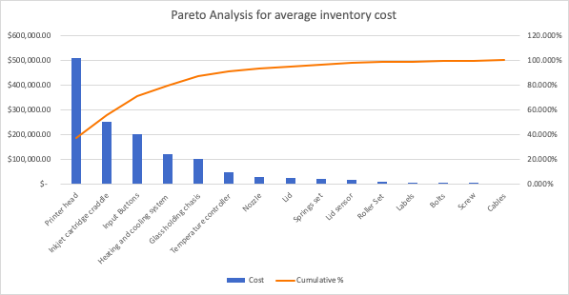

*(Figure 2: Pareto Chart)*

The purpose of the Pareto chart is to highlight the most important among a (typically large) set of factors ("Pareto chart," 2018). In [quality control](https://en.wikipedia.org/wiki/Quality_control), it often represents the most common sources of defects, the highest occurring type of defect, or the most frequent reasons for customer complaints, and so on. The left vertical axis is the [frequency of occurrence](https://en.wikipedia.org/wiki/Frequency_probability), but it can alternatively represent cost or another important [unit of measure](https://en.wikipedia.org/wiki/Units_of_measurement). The right vertical axis is the cumulative percentage of the total number of occurrences, total cost, or total of the particular unit of measure ("Pareto chart," 2018). Because the values are in decreasing order, the cumulative function is a [concave function](https://en.wikipedia.org/wiki/Concave_function).

## Fishbone diagram:

Fishbone Diagram is an essential part of the analyze phase. It helps in classifying the possible causes of a problem by identifying the root cause. In this process, the six main causes are classified as: Equipment/Supplies, Materials, Methods, Machines, Manpower and Environment.

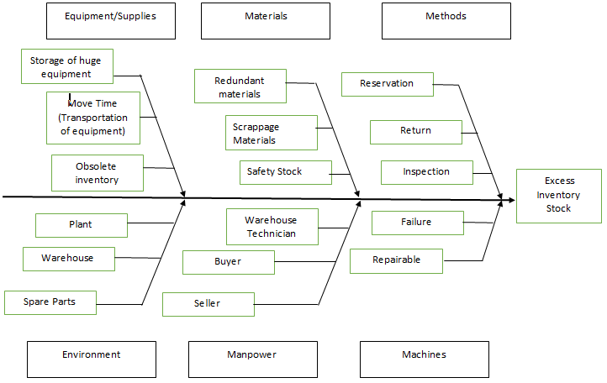

*(Figure 3: Fishbone Diagram)*

* **Equipment/Supplies:** Storage of huge equipments implied that there was a need for an expensive floor space which in turn increased the inventory cost. As the printer has the complex bill of material, the time required to reach these parts to the shop floor took more than 13 days. Therefore, if a particular order got cancelled and likewise a similar opportunity did not come their way, the inventory became obsolete ("Applying DMAIC to Inventory Problems | Quality Digest," 2010). The inventory if not usable was either sold or considered as scrap.
* **Materials:** Upon observing the printer we found that some of the raw materials were not being used for that particular order of that printer. They were either defective for the usage of the ongoing order or were considered as scrappage materials for a previously cancelled order. Excess safety stock had been resulting in excess inventory which also led to its timely maintenance, which in turn resulted in high inventory costs.
* **Methods:** At times as there were no similar orders in a row, the inventory for the particular orders would be stored until the time they would be utilized for the same type of order. If the inventory was not being utilized it would be either returned or sold to the required buyers. The long term containment of the inventory in the warehouses would lead to its maintenance routine. Thus, the frequent inspection of these inventory parts eventually led to an increase in the inventory costs.
* **Environment:** Since any given order takes a long time to complete, also the warehouses being located at far off places from each other and the main unit, the transportation of inventory parts took a longer time for them to complete that order resulting in excess inventory. The plant where the spare parts are located needed to be maintained and frequently checked upon to keep a track of the inventory ("Applying DMAIC to Inventory Problems | Quality Digest," 2010).
* **Manpower:** It was seen to it that an overall training about the processes to handle an order was given to the entire workforce. The workforce needed to be skilled in their respective domains to ensure an effective delivery of the order. It was seen to it that the customers’ order changes were taken into consideration at the right time without resulting in excess inventory.
* **Machines:** The downtime of the machines needed to be frequently monitored so as to reduce the inventory cost and satisfying the customer’s demand on time.

## 5-WHY ANALYSIS

5-Why is an iterative technique that is used to determine the root cause of a problem by reiterating the question “Why?”. At the end, by analyzing the questions and answers we can come up with five corrective actions that can be worked upon.

* Why is there excess inventory cost?
* There is excess inventory cost because the cost includes the expensive floor space and the maintenance cost.
* Why is there a need for expensive floor space and maintenance cost?
* There is a need for floor space to store the inventory for longer periods of time which requires proper maintenance.
* Why is the inventory stored for a longer period of time and why should there be a proper maintenance of all the inventory?
* The inventory should be maintained properly for any given order as the order completion takes a lot of time and if that order is cancelled it is then considered as scrappage or sold off.
* Why is the inventory considered as scrappage?
* If the particular order does not get finalized, then the leftover inventory increases the inventory cost, in turn resulting in scrappage of raw materials and excess inventory.

* Why is there excess inventory?
* Due to factors like huge equipment and supplies, scrappage materials, increased lead times, cancelled orders, machine downtimes and various other such factors there is increase in the inventory.

## Value Stream Mapping

Value Stream Mapping is an important tool to visualize, analyze and improve the information and material flow for the work process. The primary purpose of value stream mapping is to highlight the process areas where improvement can be done by visualizing the value-added and non-value-added (wasteful) steps (“Martin, K. and Osterling, M.”, 2014). It also helps in gaining insight into process flow as well as decision making flow which is important to reduce cycle time (“Martin, K. and Osterling, M.”, 2014)

## Value Stream Mapping before the process improvement

The core metrics values for this project were obtained through interviews with Kateeva personnel. The current state mapping of Kateeva processes is shown in the figure below. The VSM shows information and inventory flow through different stages of the processes.

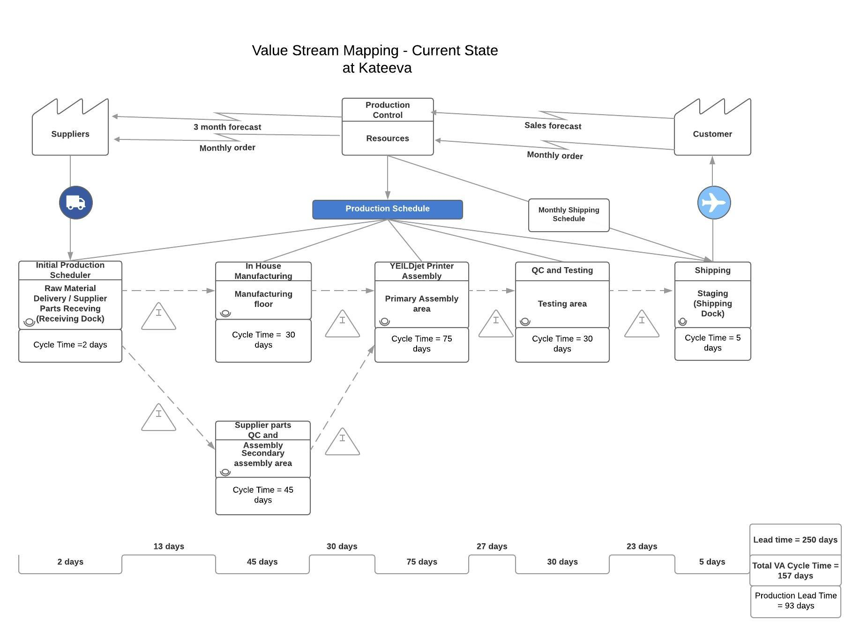

*(Figure 4: Value Stream Mapping: Before Process Improvement)*

The Process Cycle Efficiency (PCE) for current state VSM is 62.80%.

# **Improve Phase:**

Lean inventory improvement rests on five principles to achieve the ultimate goal of maximum efficiency (“Trujillo”, 2018): 1) Value: The value Lean management can provide to the business. It can either be space, time, money, effort, and/or customer satisfaction. 2) Flow: Lean inventory management modifies the system so that the inventory flow is a demand-based pull flow. 3) Pull: The only time inventory should be pulled is when a customer needs something. It helps further cut down excess inventory. 4) Responsiveness: Monitoring the inventory flow only works when the information gathered is acted up on. Adapting the changes quickly can result in quick outcomes. 5) Perfection: Perfection is the most difficult and most essential principle to master. Lean processes usually improve to perfection over years and decades of time. (REF#1)

## FMEA:

FMEA - Failure Modes and Effects Analysis is a step by step process to identify all possible failures in manufacturing or assembly process. The risk priority number (RPN) is calculated by

Risk Priority Number = Severity * Occurrence * Detection

The values for severity, occurrence and detection are allocated between 1 to 10 with 10 being the highest value.

*(Table 3: Risk Priority Number)*

|  |  |  |  |
| --- | --- | --- | --- |
| Score | Severity | Score | Occurrence |
| 1 | Unnoticed | 1 | Once every year |
| 2 | Minor to moderate consequences | 2 | Once every six months |
| 3 | Moderate to major consequences | 3 | Once every three months |
| 4 | High damage | 4 | Once every month |

|  |  |  |  |  |  |
| --- | --- | --- | --- | --- | --- |
| S  E  V  E  R  I  T  y | 4 | | 8 | 12 | 16 |
| 3 | | 6 | 9 | 12 |
| 2 | | 4 | 6 | 8 |
| 1 | | 2 | 3 | 4 |
|  | | OCCURRENCE | | | |

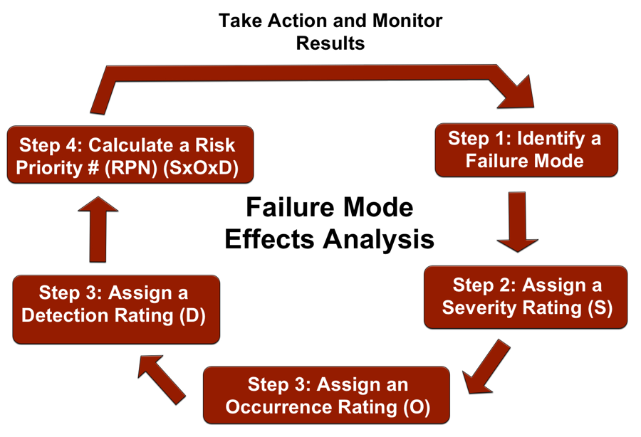

(*Figure 5: FMEA)*

FMEA is often the first step of a system reliability study. It involves reviewing as many components, assemblies, and subsystems as possible to identify failure modes, and their causes and effects ("Failure mode and effects analysis", 2018). For each component, the failure modes and their resulting effects on the rest of the system are recorded in a specific FMEA worksheet. Major benefits derived from a properly implemented FMEA effort are as follows:

* It provides a documented method for selecting a design with a high probability of successful operation and safety.
* A documented uniform method of assessing potential failure mechanisms, failure modes and their impact on system operation, resulting in a list of failure modes ranked according to the seriousness of their system impact and likelihood of occurrence.
* Early identification of single failure points (SFPS) and system interface problems, which may be critical to mission success and/or safety. They also provide a method of verifying that switching between redundant elements is not jeopardized by postulated single failures.
* An effective method for evaluating the effect of proposed changes to the design and/or operational procedures on mission success and safety.
* A basis for in-flight troubleshooting procedures and for locating performance monitoring and fault-detection devices.
* Criteria for early planning of tests ("Failure mode and effects analysis", 2018).

It is observed and analyzed from the current state VSM and data collected that the Initial Production scheduler takes more than usual time to schedule the jobs of ordering and manufacturing parts at In-House manufacturing floor. Kateeva uses NetSuite ERP solution for financial management, revenue management and billing. NetSuite ERP also features order management and inventory management functionalities. We strongly recommended Kateeva to use NetSuite ERP or other order management and inventory tracking system. After discussing the solution with Kateeva personnel, we computed that the non-value added time can be reduced to average 3 days with proper use of inventory management techniques using NetSuite. Also, as per the current business processes, Kateeva invites their clients to physically pay a visit to look at the finished product (OLED printer) and test before shipping it to the client location (mostly overseas) ("Inkjet printer - DDL Wiki," n.d.). This process adds on average 23 days (including scheduling and transit time) to the lead time before shipment is prepared. This time can be significantly reduced (3 days) if virtual demo/inspection are provided using the video conferencing tools and services to clients once their product is tested and ready. Virtual demo can remove the wastes of time and money generated at that step and would help ensure faster delivery times.

## Value Stream Mapping after the process improvement

Value Stream Mapping was created after considering that the improvement steps have been implemented. Future state VSM focuses on values as defined by the customer which helps to identify the wastes and other steps of the process which can be removed. After analyzing the measurements and current state VSM the focus remained on removing the waste generating steps and reducing the non-value added time. The future state value stream mapping as shown in the figure below. It is clearly observed from the future state VSM that improving the processes will reduce the non-value-added time by 43% i.e. from 93 days to 53 days. The Process Cycle Efficiency (PCE) is 74.76% (improvement of 11.96%).

# **Control Phase:**

## Control chart

To support the improved process, control charts can be plotted based on collected data.

Upper control limit and lower control limit can be depicted from the chart and It is shown that Manufacturing lead time before improvement chart is unstable.

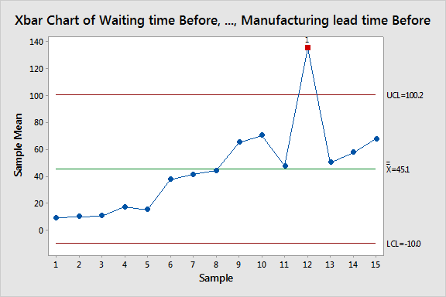

*(Figure 6: Control Chart:Lead Time-Before)*

After the lean process improvement, process is under control and comparatively stable.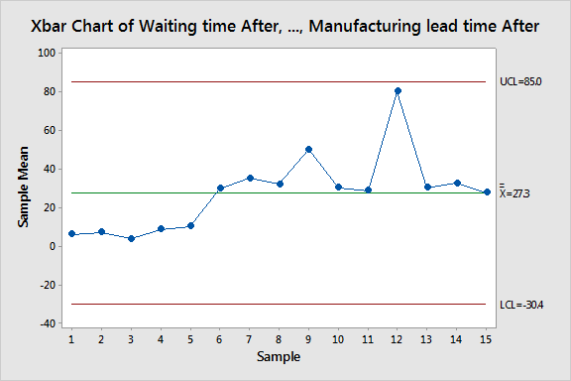

*(Figure 7: Control Chart:Lead Time-After)*

# Hypothesis Testing

For Inventory cost:

We are testing whether inventory cost before and after process improvement are statistically different or not. Here, sample size is 15 and normality was checked using normal probability plot. data is normally distributed with few outliers.

μ1= mean of inventory holding costs of average inventory before improvement

μ2= mean of inventory holding costs of average inventory after improvement

The sample size is less than 30 and variances are unknown and unequal hence T test with v degree of freedom is tested using Minitab.

Null Hypothesis: μ1-μ2=0

Alternative Hypothesis: μ1-μ2 not equal to 0

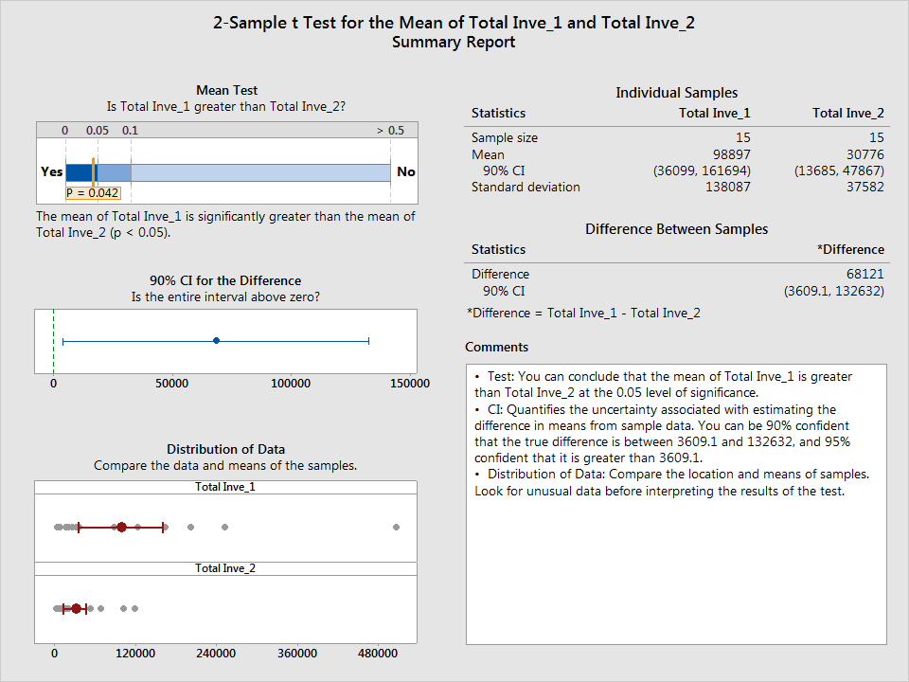

*(Figure 8: Hypothesis Testing for Inventory Cost)*

It can be concluded from the output that null hypothesis is rejected. Hence, mean of inventory cost before improvement and after improvement are statistically distinguishable at 0.05 level of significance with 90% of confidence interval.

Hypothesis testing for Lead time: Manufacturing lead time before process improvement and after process improvement are tested using paired T test since sample is dependent(paired).

Null hypothesis: μd=0 (μd is the mean of population differences)

Alternative hypothesis: μd is not equal to 0.

Minitab output is in figure. Since, zero is not included in the 95% confidence interval and p value is less than 0.05, null hypothesis is rejected.

*(Table 4: Paired t Test)*

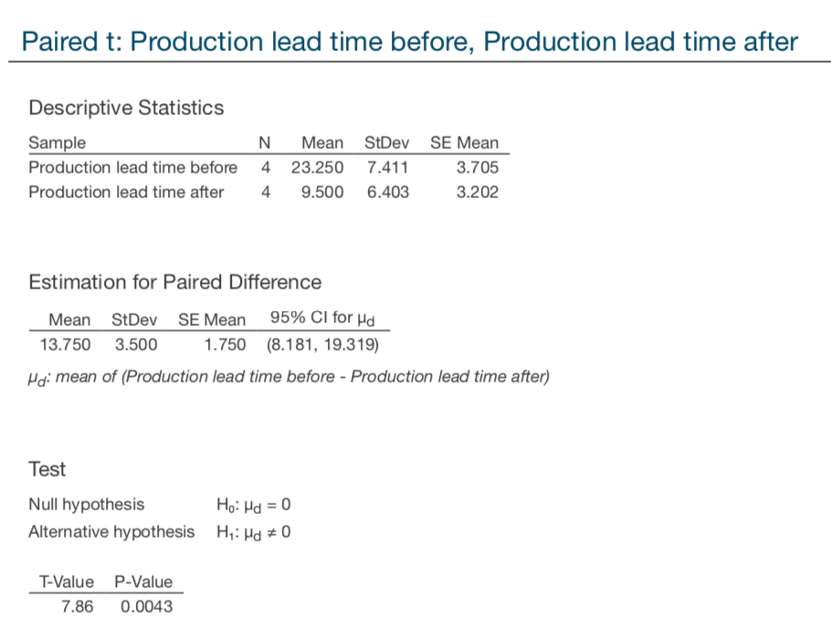

# Environmental and Economic effects:

At Kateeva, by shedding new light on the importance of indirect and dispersed cost and benefits, lean methodologies may raise awareness among managers regarding the potential benefits and cost reduction due to environmentally friendly activities. Adopting lean improvement techniques will help Kateeva become more sustainable and low waste generating organization.

# **Conclusion**

**Future improvement ideas:**

* Kateeva should consider utilizing the local suppliers for the raw material and purchased parts in order to reduce the lead time in transportation. This will also help them lower the transportation cost and damages that occur during transit.
* Kateeva should continuously improve their manufacturing and assembling operations and sequences to move towards Just-In-Time approach to decrease the waiting time of parts.
* The project team narrowed the approach to reducing the lead time and inventory cost and maintained the scope throughout the project. DMAIC analysis was used for identifying and implementing process improvements. SIPOC helped in analyzing the issues faced by the company.
* Pareto Analysis and 5-Why Analysis are used to measure the sample data and quantify the same. Additionally, Control charts are used for before and after process improvement data.
* Following are the key changes implemented in Kateeva and a reduction in lead time was achieved through these changes.
* Implementing changes in lead time
* Redesigning the process layout
* Periodic equipment maintenance
* Inventory management analysis

# **References**

1. Trujillo, P. (2018). 5 Lean Inventory Principles. Retrieved from http://www.waspbarcode.com/buzz/5-lean-inventory-principles/
2. Martin, K. and Osterling, M. (2014). Value stream mapping. New York: McGraw-Hill, pp.51-120.
3. Failure mode and effects analysis. (2018). Retrieved from https://en.wikipedia.org/wiki/Failure_mode_and_effects_analysis
4. Pareto chart. (2018, October 28). Retrieved from https://en.wikipedia.org/wiki/Pareto_chart
5. Applying DMAIC to Inventory Problems | Quality Digest. (2010, March 12). Retrieved from <https://www.qualitydigest.com/inside/twitter-ed/applying-dmaic-inventory-problems.html>
6. Lean Six Sigma to Reduce Excess and Obsolete Inventory | iSixSigma. (n.d.). Retrieved from [https://www.isixsigma.com/operations/supply-chain/lean-six-sigma-reduce-excess-and-obsolete-inventory](https://www.isixsigma.com/operations/supply-chain/lean-six-sigma-reduce-excess-and-obsolete-inventory/)/
7. Inkjet printer - DDL Wiki. (n.d.). Retrieved December 11, 2018, from [https://wiki.ece.cmu.edu/ddl/index.php/Inkjet_printe](https://wiki.ece.cmu.edu/ddl/index.php/Inkjet_printer)r

# **Appendix**



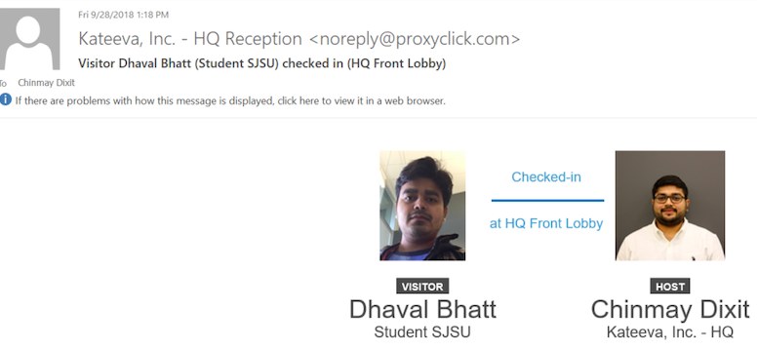



*(Figure 9: Communication)*

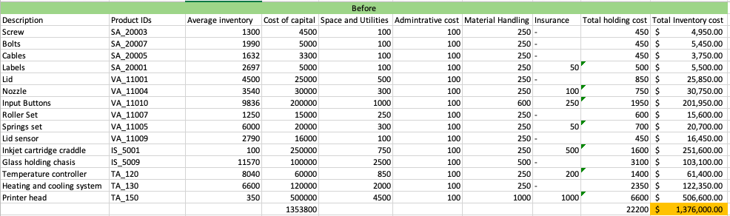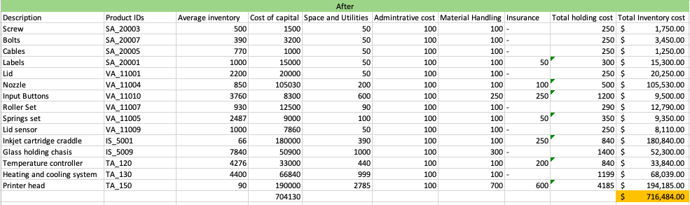

*(Figure 10: Excel of before and after cost calculation)*

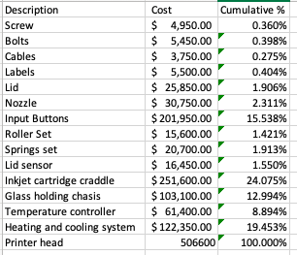

*(Figure 11: Cumulative % of Inventory cost)*

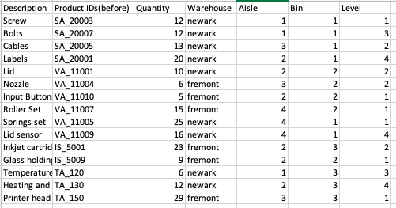

*(Figure 12: Inventory History at Kateeva)*